<https://www.thetimes.co.uk/>

The house that Don Draper built

You don’t have to be the creator of Mad Men to live here, but it helps. Matthew Weiner, the brains behind the series, replicates its mid-century aesthetic in his Los Angeles home

**Dominic Bradbury**

April 8 2017, 12:01am, The Times

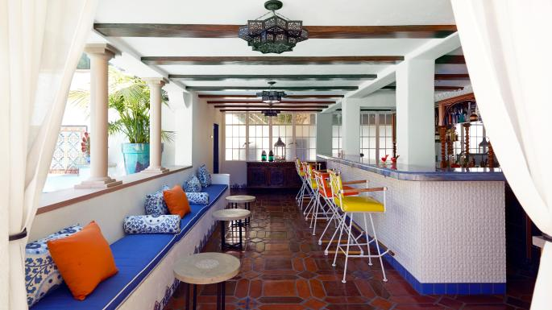

The poolside bar, with Cleo Baldon stools and Palecek tablesRICHARD POWERS

Share

Save

For a design-conscious writer like *Mad Men* creator Matthew Weiner, your surroundings really matter. Much of the appeal of the TV series, charting Don Draper’s rise through the ad agencies of Sixties New York, lay in the seductively and minutely observed world Weiner recreated for him, so it’s entirely appropriate that the study is the most alluring space of the Los Angeles home he shares with his wife, Linda Brettler.



Jon Hamm with, from left, Kiernan Shipka, January Jones and Jessica Paré in Mad Men;AMC

The glass walls of the study look out onto the gardens and pool terrace, while also enjoying longer views of the Hollywood Hills. The custom bookcases are graced with some of the Emmys and Golden Globes that Weiner has earned for both *Mad Men* and his earlier work on *The Sopranos*. Two mid-century chairs sit in front of a Victorian partners desk, while Moroccan lanterns serve as ceiling lights. It’s an eclectic and personal mix.

“It’s great to have my own space, with spectacular views, and to be surrounded by my books,” says Weiner, who recently completed his first novel, *Heather, the Totality*, which will be published this autumn. “It’s a very happy house. I have a vivid imagination and can be up at all hours of the night, yet there’s no space in the house that feels uncomfortable. It’s amazing that with all the work we have done to the place, it still feels so organic and authentic.”

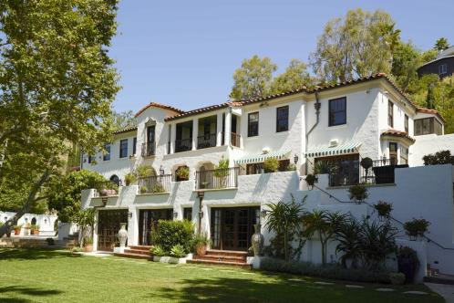

The exteriorRICHARD POWERS

Weiner and Brettler, who both grew up in LA, share a passion for architecture and design. That includes mid-century modern, which played such a key role in the look and feel of *Mad Men*. Weiner brought a few things home from the set when the show ended, including Peggy’s stapler and Don Draper’s Clio Award, along with his characters’ business cards. And where would a house inspired by Mad Men be without a drinks trolley?

“Growing up in LA, my love of mid-century architecture has formed much of my taste in general, not just as part of *Mad Men*,” says Weiner. “So many mid-century landmarks were gone by the time we started the show that I made conservation a priority in my personal and professional life.”

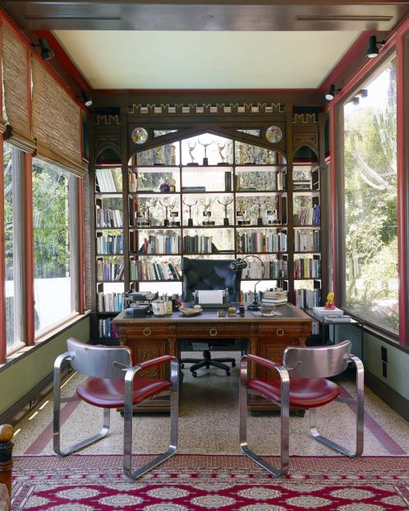

The study, with bookcases designed by Linda BrettlerRICHARD POWERS

The family used to live in a much smaller property, dating from the Thirties, in the Fairfax district of LA. But with four boys – one of whom, Marten, made regular appearances as Glen Bishop in *Mad Men* – space became a big issue.

“Because our family was blossoming, we really needed more bedrooms and more living space,” says Brettler, who runs her own architectural practice. “My husband had to give up his office in the old house so that we could convert it into a bedroom. As he’d often joke, his office was his bed. But also, with four sons, we really wanted a bigger garden and outdoor area.

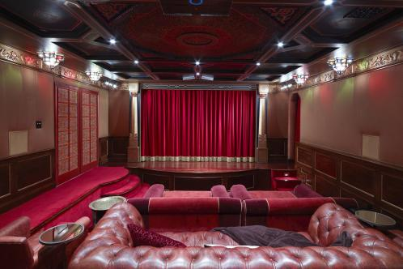

The 25-seat home cinemaRICHARD POWERS

“Now, Matthew and I each have our own offices, plus a vast amount of space for entertaining family and friends. And having a basement was an opportunity to make Matthew’s dream come true and create a 25-seat cinema. Most of all, we get to enjoy the trees, the views, the flora and the fauna.”

Its generous scale, character and setting drew Brettler and Weiner to the Spanish colonial-style villa, which dates from the Twenties and comes with quite a Hollywood history. One of its residents was Joan Crawford, and the original garden was shaped by a Disney set designer. At various points in its history it served as a base for Motown records and the Reverend Sun Myung Moon, the founder of the Moonies. By the time that Weiner and Brettler saw the house it had been sitting on the market for some time and was showing signs of “benign neglect”.

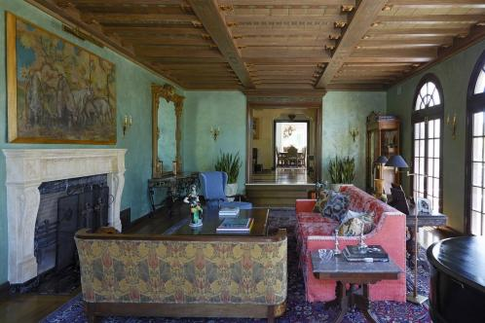

The sitting room, with Paolo Buffa blue armchair and painting from the Canadian Museum of NatureRICHARD POWERS

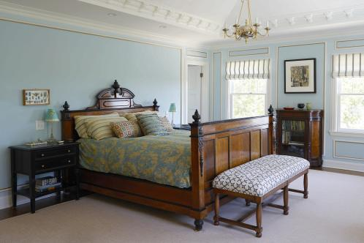

The master bedroomRICHARD POWERS

“Necessary upgrades and repairs had never been made and inappropriate renovations had compromised the integrity of the house,” says Brettler. “The inspection report that we had done totalled 400 pages. It was the kind of large-scale project that probably only an architect would undertake, and that worked in our favour. It was a huge plus for me, as I got to keep some of the original portions of the house while having the freedom to design new and interesting spaces in other parts.”



Matthew Weiner and Linda BrettlerGREY CRAWFORD

The ground-floor rooms were pepped up by a vivid use of colour and texture, while preserving as many period elements as possible. The upper level was totally remodelled to create a more pleasing set of family bedrooms and bathrooms, while the eclectic blend of furniture adds to the timeless feel of the home. The lower ground level, which leads out to the pool terrace and garden, was also radically reworked, with a welcoming loggia-style lounge and bar, plus the new family cinema.



The poolRICHARD POWERS

“The theatre is an amalgam of all the theatres that I admired when I was growing up,” says Weiner. “It’s even got a candy room that’s fully loaded. I also made sure that the kids’ video games would be in a separate space. The theatre only functions as a haven for watching movies and television.”



The terraceRICHARD POWERS

[*lindabrettler.com*](http://www.lindabrettler.com/)*.*Heather, the Totality*, by Matthew Weiner, will be published by Little, Brown in November*